Copy of GCO and GIII

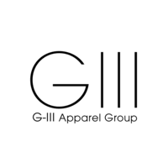

Date: November 10, 2020 Forward P/E: 6.8858

Company Ticker: GIII Sector Forward P/E: 9.70

Sector: Consumer Discretionary Market Price: $17.11

Industry: Retailing Forecasted Price: $44.40

**Company Summary**

G-III Apparel Group is a manufacturer and distributor of outerwear, dresses, sportswear, swimwear, women’s suits and women’s performance wear. The company also sells footwear, luggage and women’s handbags, small leather goods and cold weather accessories. G-III operates across two main business segments: wholesale operation and retail operations.

**Industry Outlook**

G-III, like other consumer discretionary firms, operates in industries that rely on disposable income. As the economy recovers from the coronavirus, disposable income will increase, which will likely lead to revenue growth for apparel manufactures & distributers like G-III. Store closings across this sector have led to decreased revenues throughout this year. As most stores across the countries are reopened, companies are beginning to earn brick-and-mortar revenues again.

**Earnings Forecast**

The earnings forecast for G-III is based on various drivers, such as SG&A as percentage of sales, net fixed assets as percentage of sales, etc. (see our earnings forecast to view and interact with all drivers and assumptions). Again, while some of these drivers are standard, some are firm/industry specific. An example of a firm specific driver for G-III is “total G-III stockholders’ equity (deficit) – Trends”. Almost all line entries are based on the drivers mentioned above, which are based on historical averages and regression analysis.

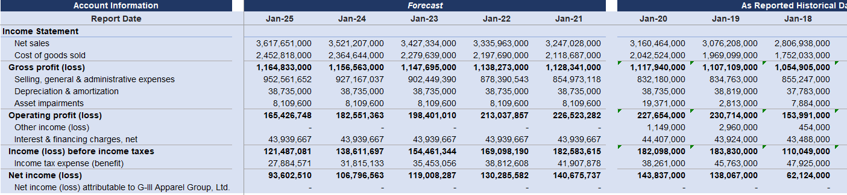

**Valuation**

A standard long term FCFE growth rate of 3.50% is used, while the short-term growth rate comes from historical trends (averages) year over year. The short-term growth rate we calculated was 2.74%. The Cost of equity is dependent on the long-term growth rate and the firm forward P/E ratio. The cost of equity we calculated was 13.81%. The sector forward P/E ratio was pulled from Yardini research.

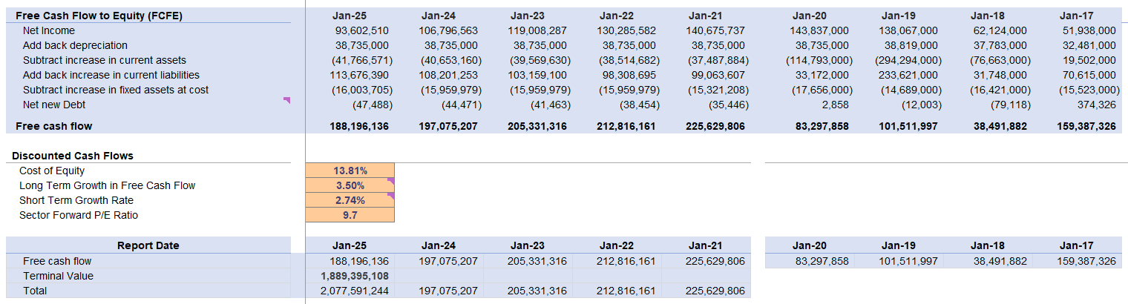

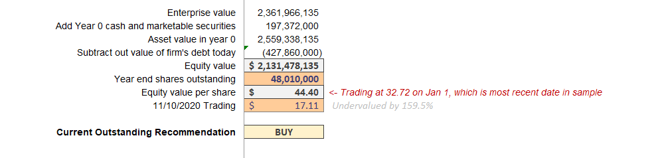

**Sensitivity Analysis**

While we have an idea of what the most likely equity value, and subsequently, the equity value per share is, we have also sketched out other equity values, and the probabilities of these values. The equity value per share that we believe to be most likely is $44.10.

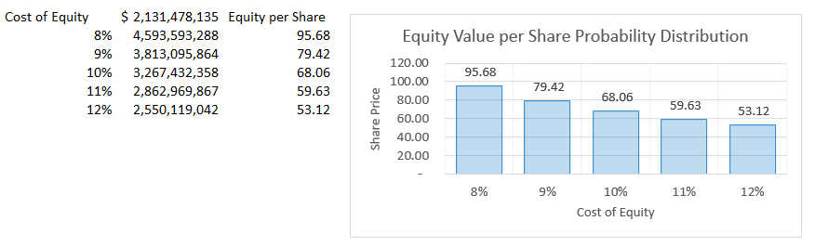

**Conclusion**

Based on our analysis and computations above, we recommend the fund purchase shares of G-III. We believe the shares are undervalued by around 160%, with an equity value per share of $17.11, versus a market value of $17.11.



Date: November 10, 2020 Forward P/E: 7.4144

Company Ticker: GCO Sector Forward P/E: 9.70

Sector: Consumer Discretionary Market Price: $23.03

Industry: Retailing Forecasted Price: $47.87

**Company Summary**

Genesco Inc. sources, designs, retails, and wholesales footwear, headwear, sports apparel and accessories. Genesco markets its products through own retail stores, e-commerce portals and catalogs under Johnston & Murphy, H.S. Trask, Lids, Journeys, and Little Burgundy brand names. Genesco operates under four reportable segments: Journeys Group, Johnston and Murphy Group, Schuh Group, and licensed brands.

**Industry Outlook**

Genesco primarily operates in the following industries: shoe stores and hat stores. Hat & Cap stores are projected to grow in revenue over the next five years, but that rate has been decelerated following the pandemic. An increase in the number of adults in the US is another reason the industry is expected to grow. The shoe store industry is also set to experience revenue growth for similar reasons, but has higher levels of competition, which could lead to less revenue growth on a firm to firm basis.

**Earnings Forecast**

The earnings forecast for Genesco is based on various drivers, such as sales growth percentage year over year, cost of goods sold as percentage of sales, etc. (see our earnings forecast to view and interact with all drivers and assumptions). In a slight difference compared to the other firms analyzed, none of the drivers for Genesco’s earnings forecast are very firm-specific. Almost all line entries are based on the drivers mentioned above, which are based on historical averages and regression analysis.

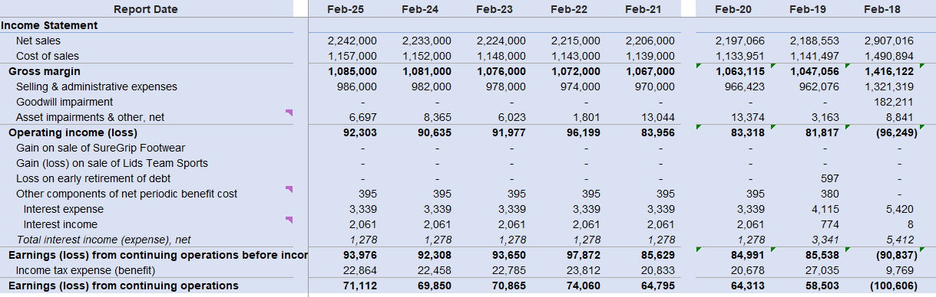

**Valuation**

A standard long term FCFE growth rate of 3.50% is used, while the short-term growth rate comes from historical trends (averages) year over year. The short-term growth rate we calculated was 0.39%. The Cost of equity is dependent on the long-term growth rate and the firm forward P/E ratio. The cost of equity we calculated was 13.81%. The sector forward P/E ratio was pulled from Yardini research.

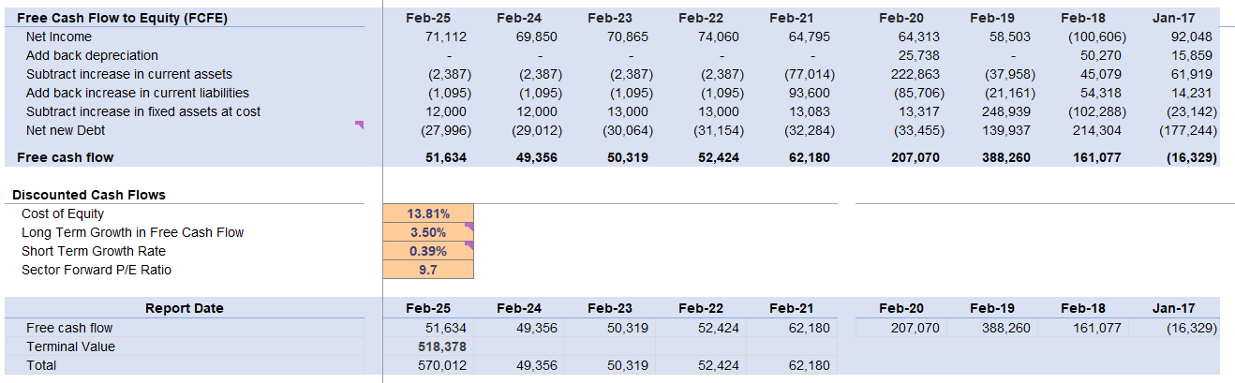

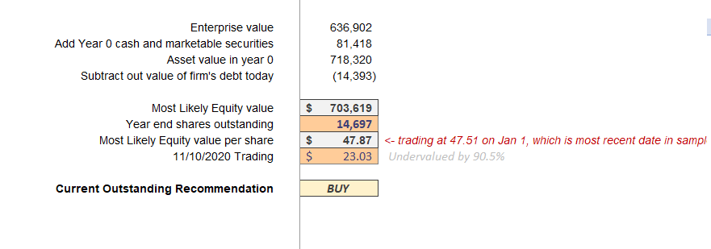

**Sensitivity Analysis**

While we have an idea of what the most likely equity value, and subsequently, the equity value per share is, we have also sketched out other equity values, and the probabilities of these values. The equity value per share that we believe to be most likely is $47.87.

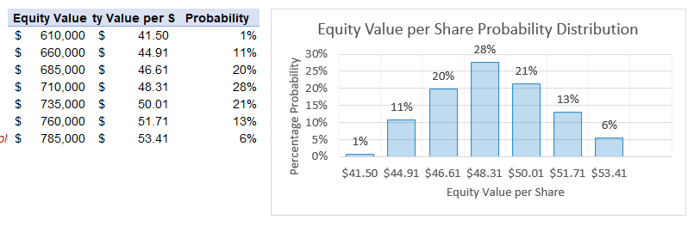

**Conclusion**

Based on the analysis and computations above, we are recommending the fund purchase shares in Genesco. We believe the shares are undervalued by 90.5%, with a equity value per share of $47.87, compared to a market value of $23.03.